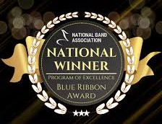
CUTHBERTSON | Todd Ebert, Director of Bands  Katie Ebert, Assistant Director  Samantha Liddle, Associate Director  Cuthbertson High School  1400 Cuthbertson Road  Waxhaw, NC 28173  Cuthbertsonbands.org
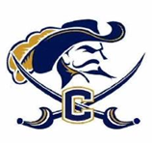
BAND
We are so excited to get this season started for all of our students and we hope you will consider joining one of the following two ensembles this fall! Go Band Go!
Friday Night Lights 2026 season
Friday Night Lights Pep Band is an exciting and energetic experience that brings all of our musicians together! Playing in the stands, hyping up the crowd, and being part of the home game day atmosphere makes every Friday night fun and full of memories. Members even have opportunities to perform at halftime with fun, popular music that gets everyone on their feet. It’s a fantastic way to share your love of music, create amazing memories, and build lasting friendships along the way. Friday Night Lights is all about fun music, great vibes, school spirit, and having an incredible time together!

Mighty Marching Cavaliers 2026 season
Competitive marching band is one of the most exciting and rewarding experiences our band program has to offer. From performing under the Friday Night Lights to traveling for competitions, parades and other events, students build unforgettable memories while being part of something bigger than themselves. Beyond the fun, marching band develops important life skills such as leadership, teamwork, time management, discipline, and perseverance. It also provides a strong social outlet where students form lasting friendships and feel a true sense of belonging. As an added benefit, students who participate in marching band can use that experience to go toward earning their honors credit for the band curriculum.

Friday Night Lights is an entirely fun ensemble with an emphasis on having a great time and sharing fun music with our school at home games and parades. We have dinner and cake before all of our games where we get to really enjoy our time with each other and build lasting friendships.
Competitive Marching Band is equally as fun and incorporates music, movement, teamwork, and performance into one exciting experience. This ensemble requires more time and practice since it is a competition based band. Beyond the performance, competitions mean bus rides, inside jokes, and bonding with people who share the same passion. You build confidence, discipline, and friendships that last long after the season ends.
Fall Marching Band Participation Information
*Open to rising 8th grade through rising 12th
*Levels of participation designation and expectations for participation in each level
*Training information and spring/fall start dates
*Full season schedules for both FNL (Friday Night Lights) and Mighty Marching Cavaliers (MMC)
*Payment information sheet
*Health Form
*Permission Forms

2026 Spring training - Friday Night Lights & Mighty Marching Cavaliers
ALL Friday Night Lights students are expected to be present for all rehearsals listed on their ensemble schedule.
Friday Night Lights has an abbreviated schedule and Mighty Marching Cavaliers have the full seasons schedule.
Any conflicts should be discussed with Mr. Ebert as early as possible in order to be considered excused. Students need to be picked up no later than 15 minutes after the rehearsal ends.
- Check your calendars! Routine doctor and dentist appointments are not considered excused and therefore should not be scheduled during rehearsal time.
- In order to count an absence as excused, special permission must come from Mr. Ebert and be considered an emergency situation. Any special emergencies should be addressed ONLY to Mr. Ebert via email or direct phone call.
- Unexcused absences will result in a possible loss of field placement/performance privilege.

Performance Uniform Information
All new marching students will receive the following items as part of the Friday Night Lights uniform:
Performance season T-Shirt
Performance hoodie/jacket
Performance cap
Students will supply their own black shorts/pants and shoes for FNL performances.
*Returning students to FNL that need replacements may purchase them from the Band Boosters.
Competitive Marching members will also be sized for the marching band uniform.
Sections will be sizing uniforms from 4pm to 5pm on one of the fall training dates.

Friday Night Lights Schedule
Home Football Games, Union County Preview, and Parades

Spring Training Dates:
Time - 4:15pm to 6:00pm on Mon & Thurs.
April 20
April 23
April 27
April 30
May 4
May 7
May 11
May 18
May 21

Fall Camp Dates:
Time - 4pm to 8pm
August 17
August 18
August 19
August 20
August 21

Friday Night Football Schedule
(All of the following dates for games will have a rehearsal after school starting at 4:30pm in the Stadium. Kick off for games is 7pm.)

August 28, 2026
Home vs. Parkwood

September 4, 2026
Home vs. Cox Mill

September 18, 2026
Home vs. Porter Ridge

September 19, 2026
Union County Preview - Honors Credit Assessment

October 2, 2026
Home vs. Sun Valley
*Homecoming*

October 30, 2026
Home vs. Marvin Ridge
*Senior Night*

Potential Playoff Dates
November 7, 2026 - Round 1
November 14, 2026 - Round 2
November 21, 2026 - Round 3
November 28, 2026 - Round 4
December 5, 2026 - Regionals
December 13, 2026 - Championships
(FNL will only participate in play offs if they’re at home)

Parades
Will update when dates are posted online!
Nov. 22 or 29, 2026 - Monroe Parade
Dec. 13, 2026 - Waxhaw Parade

Mighty Marching Cavaliers Schedule
All FNL events plus away games and marching band competition
MMC will only be open to high school students

Spring HS Leadership Training Dates:
Time - 3:15pm to 4:15pm on Mon & Thurs
April 20
April 23
April 27
April 30
May 4
May 7
May 11
May 14
May 18
May 21

*NEW* Fundamentals Week (all members):
3:30pm-6:00pm
June 1-4, 2026
(Rising 9th Graders will join after MS dismissal)

Band Camp Dates:
Time - 8am to 11am *Break* 4pm to 8pm
August 10
August 11
August 12
August 13
August 14

Football Schedule

(All dates for games will have rehearsal after school at 4:30pm. Kick off is 7pm.)

August 28, 2026
Home vs. Parkwood

September 4, 2026
Home vs. Cox Mill

September 11, 2026
Away @ Forest Hills

September 18, 2026
Home vs. Porter Ridge

September 25, 2026
Away @ Piedmont

October 2, 2026
Home vs.. Sun Valley
*Homecoming*

October 9, 2026
Away @ Weddington

October 30, 2026
Home vs. Marvin Ridge
*Senior Night*

Potential Playoff Dates
(MMC may travel to in-county away games for play-off rounds.)
Nov. 7, 2026 - Round 1
Nov. 14, 2026 - Round 2
Nov. 21, 2026 - Round 3
Nov. 28, 2026 - Round 4
Dec. 5, 2026 - Regionals
Dec. 13, 2026 - Champs

Parades
Will update when dates are posted online!
Nov. 22 or 29, 2026 - Monroe Parade
Dec. 13, 2026 - Waxhaw Parade

Competitions
Sept 19 - Union County Preview
Sept 26 - Low Country Invitational (Wando)
Oct 10 - AC Reynolds
Oct 17 - East Tennessee BOA Regional *tentative*
Oct 24 - JM Robinson/Porter Ridge

*If you are planning to take the SAT please avoid the dates that conflict with this schedule.*
*Weekly practice is set to be Mon, Tues, Wed from 3:30-6:30pm. We are awaiting field availability and plan to be outside for drill on Monday and Wednesday. Tuesday will be inside for music and movement.*

Cost for each ensemble:

Friday Night Lights - New membership $150 / Returning members $75
New members will receive a uniform jacket, t-shirt, and hat
Returning members may purchase needed replacement items from Boosterhub
All members will need to provide their own pair of solid black shoes
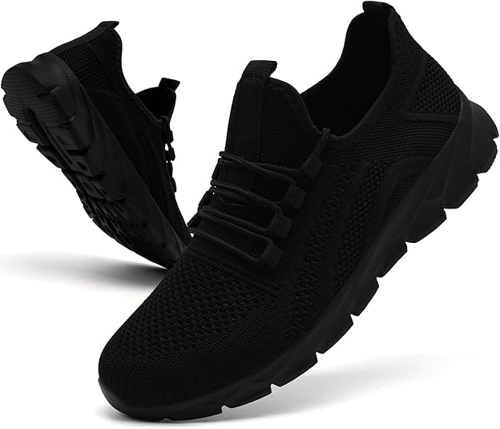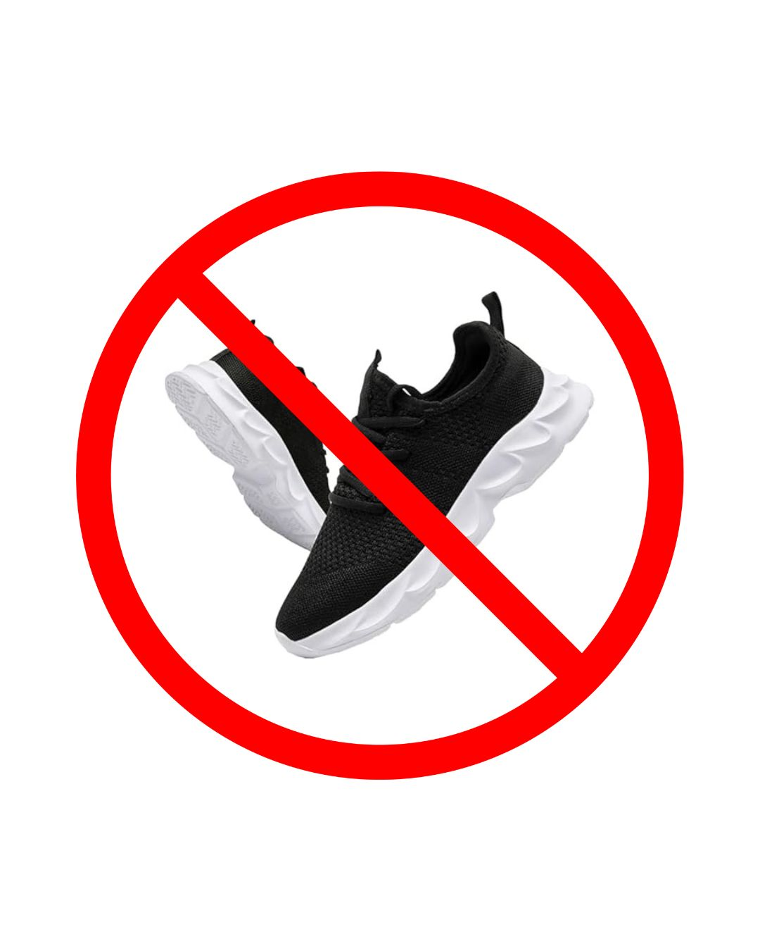

Mighty Marching Cavaliers - Additional $350
Must participate and pay for FNL to compete
This cost covers all the additional items for the competitive season

Parents
- Make sure your child's marching band payments are completed. Visit the Booster Hub app to make a payment.
- Volunteer to help! Top groups include the Pit Crew, Chaperones, and fundraising opportunities. Email our band boosters at cbbvp@cuthbertsonband.org to join a group.

Students
MMC Fall training begins August 10th.
- On your instrument- work breathing, fundamental sound, marching volume (loud!) and begin memorizing the show music . Show up to camp with your instrument oiled and greased.
- Percussion - make sure and practice your fundamentals and sticking.
- Guard- do stretches and spin basics. Work your angles and planes - make sure you count. Practice marching and spinning at the same time and stay in step. Put on your favorite song and march. This week add tosses - make sure to get the correct number of rotations and catch!

- Let's get in awesome shape for an awesome season. Do 20 push ups daily and if you have a big instrument, hold it in playing position at attention for 5 minutes at a time. Add 1 minute per day. On day 3 add 30 uppies per day and work daily to achieve a 3 minute plank by band camp.
- Also, refresh your marching fundamentals. Goal- marching and playing! Practice position of attention (pulled up from waist and shoulders down and back), forward march (upper body high), backwards march (straight leg), and mark time (heel only comes off the ground a little). Stretch your slide muscles with the slow twist then do slides- make sure your shoulders are at 90 degrees (use a mirror to check). USE THE VIDEOS!!!
- Make sure to spend some time outdoors to get acclimated to outside weather! You need to be outside at least an hour a day.

*ATTENDANCE POLICY FOR MMC*
As mentioned above, Mr. Ebert is the only person who can excuse an absence; parents must email. If a student acquires 3 unexcused absences, they will be dismissed from the competitive ensemble. The competitive band fee will be forfeited in this case and the student will move to Friday Night Lights only. Having consistent attendance is important to the success of our program and will allow us to achieve a higher level of performance. Competitive Marching Band and participation in Union County Preview fulfills a portion of the honors credit requirement.

For all questions please reach out to Mr. Ebert @ Todd.ebert@ucps.k12.nc.us
Go Band Go!!!
Todd Ebert
Director of Bands
Cuthbertson HS

CUTHBERTSON MARCHING BAND
2025-2026 SCHOOL YEAR
STUDENT INFORMATION
Circle one: Friday Night Lights Mighty Marching Cavaliers
Student's Name: Last:____________________________ First: ________________________MI: ______
Cell Phone: E-Mail: _______________________________
MB Instrument:_______________________________________ Grade: ________
Father's Name: Last: ____________________________ First: _____________________________
Home Phone: Work Phone:
Cell Phone: E-Mail:
Mother's Name:: Last: ____________________________ First: ______________________________
Home Phone: Work Phone:
Cell Phone: _ E-Mail:
Additional Emergency CQntact (if parents cannot bfl reachfld):
Name: Phone No(s):___________________________

MEDICAL INFORMATION AND CONSENT FOR MEDICAL TREATMENT
List all known allergies (food, medications, etc.):
___________________________________________________________________________________
___________________________________________________________________________________
List special medical problems:
___________________________________________________________________________________
___________________________________________________________________________________
List any medication the student is presently taking and its purpose:
___________________________________________________________________________________
___________________________________________________________________________________
TO WHOM IT MAY CONCERN:
I give my permission to the Band Directors, to act as a guardian in the event of an accident involving my child until I am able to be contacted. Also, in the event of an emergency, he/she has my permission to consent to the attending physician/emergency response team to administer any medications or perform any treatments, at my expense, that he/she deems necessary for the proper care and well-being of my child.
Signature of Parent/guardian: Date: ______________
Medical Insurance Carrier: _______________________________ Policy No. _____________________
Subscriber Name: Group/Plan No.____________________
Current Physician: Phone:________________________

PARTICIPATION AND TRANSPORTATION PERMISSION

I hereby give permission and understand the expectation that will attend all events with the Cuthbertson High School "Friday Night Lights" and/or "Mighty Marching Cavaliers" for the 2026/27 school year. I waive liability of the school, staff, or Cuthbertson Band Boosters for injury or damage sustained by my student or her/his possessions during trips or other activities.
I understand the Marching Band Handbook is online and is the responsibility of the student to read it and follow all rules stated within. I also understand that 100% participation for my student on all practice and performance days is vital and mandatory to the band program. I also grant full permission for my child to be an active member of the Cuthbertson High School "Friday Night Lights" and/or "Mighty Marching Cavaliers". I have read the Rules and Regulations in the Marching Band Handbook concerning my student's behavior and understand that failure to follow the rules will result in disciplinary action.
I understand that all Marching Band Payments are non-refundable.
Signature of Parent/Guardian: Date: ____________
Signature of Student: Date: _____________
Musically yours,
Todd Ebert, Director of Bands Todd.ebert@ucps.k12.nc.us
Katie Ebert, Assistant Director Katie.ebert@ucps.k12.nc.us
Samantha Liddle, Associate Director Samantha.liddle@ucps.k12.nc.us
National Band Associations Blue Ribbon of Excellence Program 2015-16 / 2024-25
National Association for Music Merchants “Best Communities” Merit Award 2015/16/17/18/19/20/21/22/23/24
The American Prize for High School Concert Band Recipient 2020/21/23

